 | Your family. | About your summer vacation. | Your favorite subject. | One place you would like to travel and why.
Tell Us About… |  | 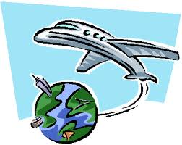 |  | Something you would like to own.
What’s one random and strange fact about you? | The best vacation you’ve ever been on. | Name three positive things that happened to you last year. | What did you bring for lunch? | Move forward one
Skip a turn | 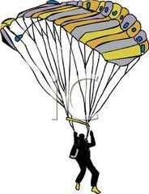 | 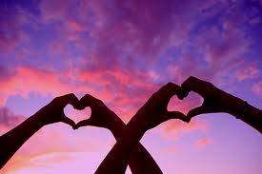
What’s something you’ve always wanted to try? | A job you would like. Why? | Your favorite colour. | If I could live anywhere in the world I would want to live in…because… | Move forward one
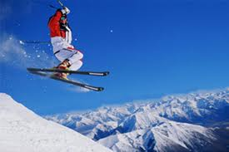 |  | 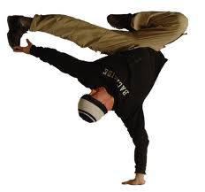 |  | If your house burnt down what three possessions (things you own) would you miss the most?
 | What are you most afraid of? | Skip a turn | Ask someone any question! | Do you have any special talents (dancing, playing an instrument, cooking, etc.)

