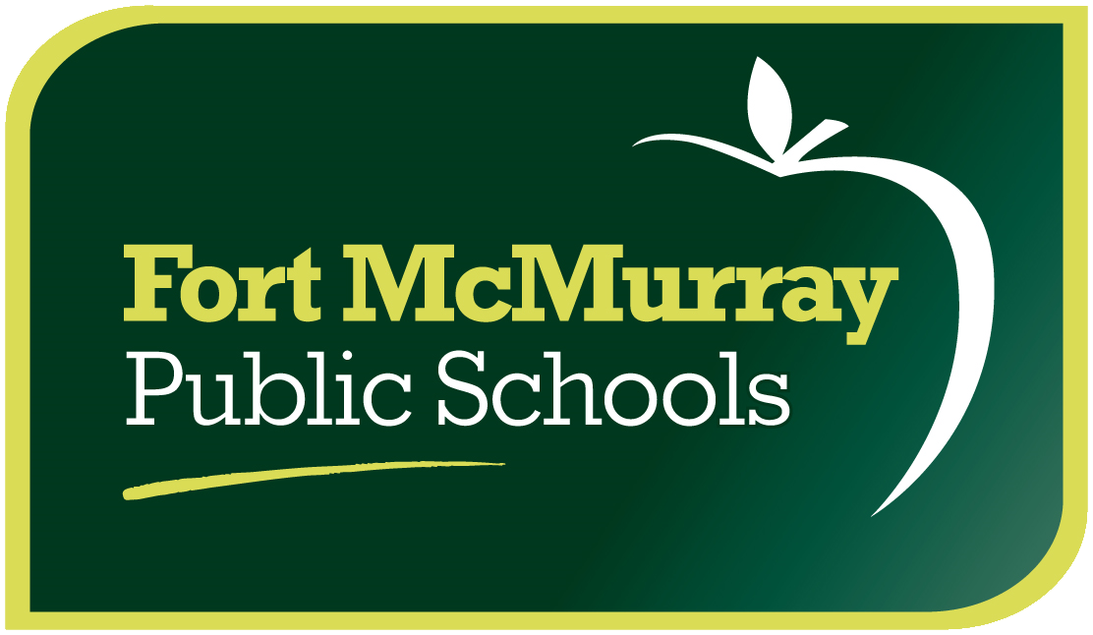

August 31, 2015

Dear Parents/Guardians,

We are very excited to offer your child the opportunity to participate in a field trip to Sustainival, the world’s first green carnival.

On the afternoon of Friday, September 4th Sustainival will be opening its doors to your child’s class to participate in their Educational Attractions. FMPSD would like to thank the Fort MacKay Group of companies for sponsoring this field trip. Busses will depart from the school at 11:30 am and students will be picked up at the Sustainival Fair Grounds at MacDonald Island at 2:00 pm. Students will be given a wristband so they can go on all of the attractions in the afternoon, however, the wristband is valid all day so they can return in the evening and continue to ride for free.

Students will have the opportunity to play carnival games and educational games that focus on sustainability. One of the attractions, the Bag Jump, requires a parent waiver to be signed as students can jump from a height onto a large bag. The waivers will be provided later this week.

An information package will be posted on Mr. Rutledge’s class blog at mrrutsclass.weebly.com
Please sign and return this form by Wednesday, September 2.

I give my child permission to attend the Sustainival Field Trip on September 4th at MacDonald Island Park.

Student Name:___________________________________ _________________________________
School Name:_____________________________________________________________________
Home Phone number/alternate phone number:___________________________________________
Parent(s) Name(s):_________________________________________________________________
Parent signature:___________________________________________________________________
I, ________________, am interested in volunteering as a Parent Chaperone for the: Sustainival Field Trip at

MacDonald Island Park on September 4th. I can be contacted at ______________________________ email/phone for more information.

